**PIZZA SALES SQL QUERIES**

A. KPI’s

1.Total Revenue

select sum(total_price) as Total_Revenue from pizza_sales

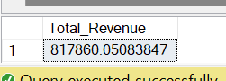

2.Average order value

select (sum(total_price)/count(distinct order_id)) as Avg_ord_value from pizza_sales

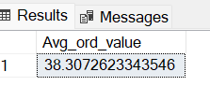

3.Total Pizzas sold

select sum(quantity) as Total_pizza_sold from pizza_sales

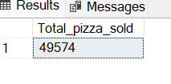

4.Total Orders

select count(distinct order_id) as Total_orders from pizza_sales

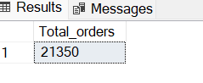

5.Average Pizzas per order

select cast(cast(sum(quantity)as decimal(10,2))/cast(count(distinct order_id)as decimal(10,2))as decimal(10,2))as Avg_pizzas_per_order from pizza_sales

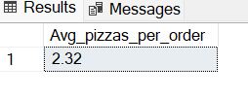

**CHART REQUIREMENTS**

**A. Daily Trend**

select datename(DW, order_date)as order_day ,count(distinct order_id) as Total_orders from pizza_sales

group by datename(DW, order_date)

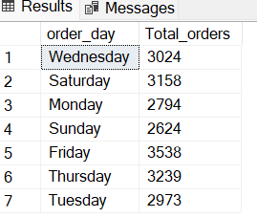

**B. Hourly Trend**

select datepart(hour,order_time)as hourly_orders, count(distinct order_id)as Total_orders from pizza_sales

group by datepart(hour,order_time)

order by datepart(hour,order_time)

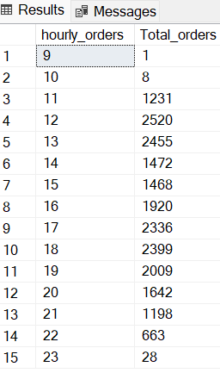

**C. % Sales by pizza category**

select pizza_category,sum(total_price)as total_sales, (sum(total_price)*100/

(select sum(total_price) from pizza_sales where month(order_date)=1))as PCT from pizza_sales

where month(order_date)=1

group by pizza_category

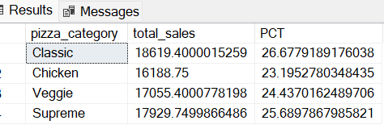

**D. Category wise total pizza sold**

select pizza_category, sum(quantity)as Total_pizza_sold from pizza_sales

group by pizza_category

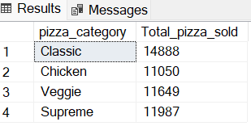

**E. Sales by pizza size**

select pizza_size,cast(sum(total_price)as decimal(10,2))as total_sales, cast((sum(total_price)*100/

(select sum(total_price) from pizza_sales where datepart(quarter,order_date)=1))as decimal(10,2))as PCT from pizza_sales

where datepart(quarter,order_date)=1

group by pizza_size

order by PCT desc

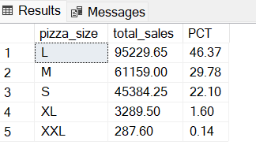

F. Top 5 selling pizzas

select top 5 pizza_name, sum(quantity)as total_sold from pizza_sales

group by pizza_name

order by sum(quantity) desc

